*&---------------------------------------------------------------------*  
*& Report  ZGT_CLASS2  
*&  
*&---------------------------------------------------------------------*  
*&  
*&  
*&---------------------------------------------------------------------*

1.Create a classs. Create method.

  . 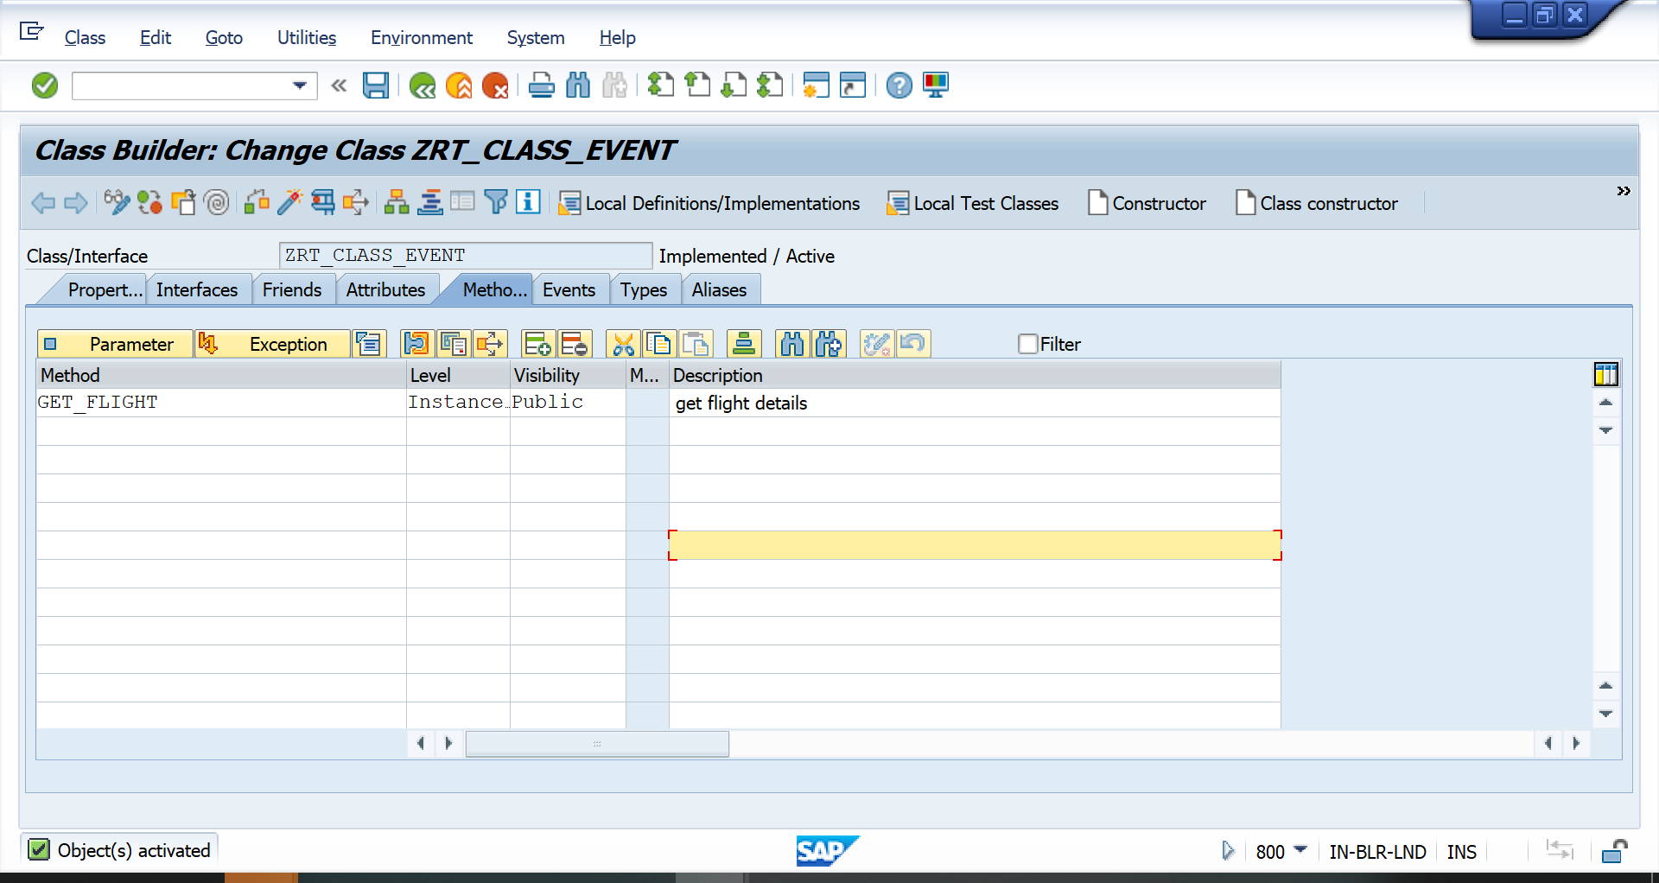

3.Create parameters for the method

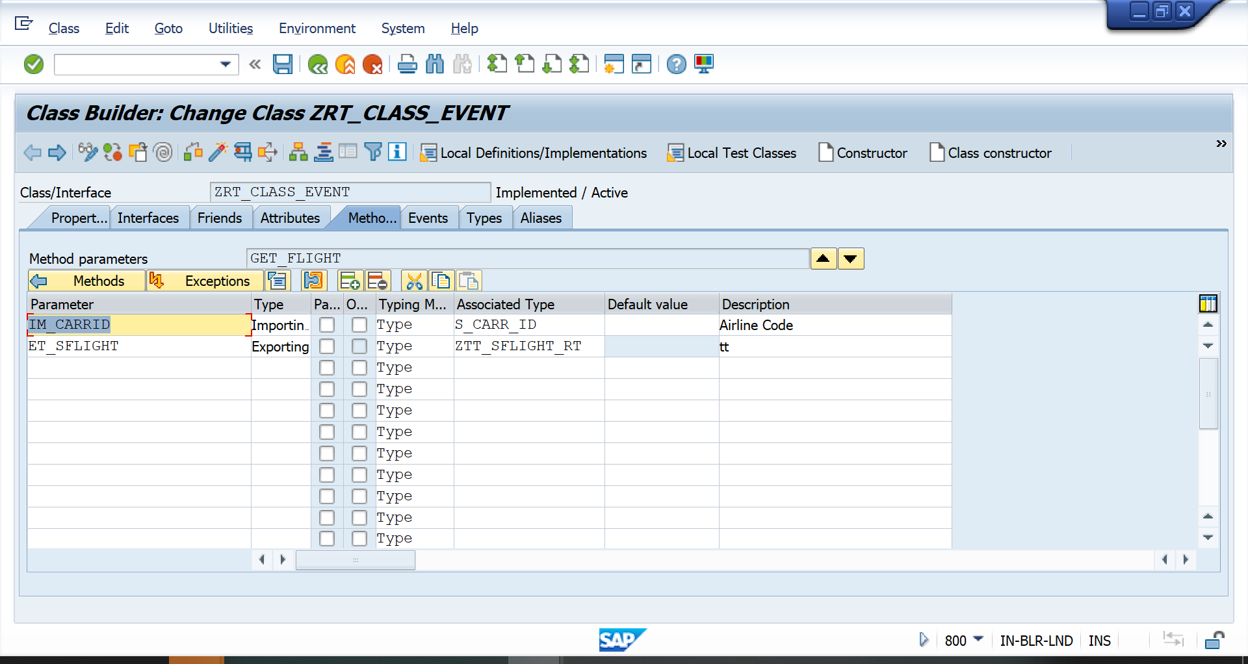

4. Add logic in the method.

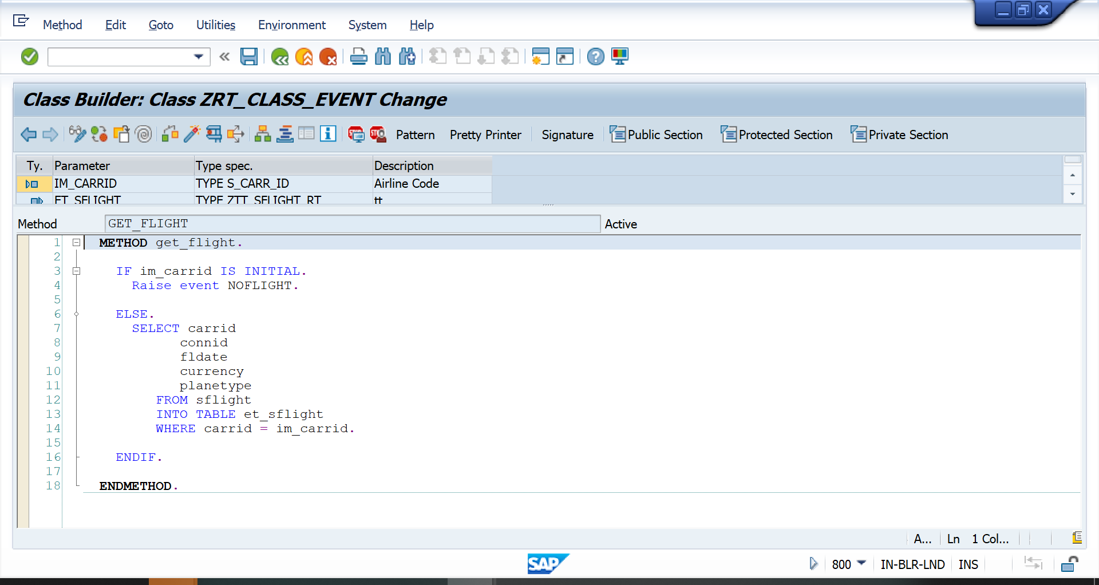

  METHOD get_flight.  
  
    IF im_carrid IS INITIAL.  
      Raise event NOFLIGHT.  
  
    ELSE.  
      SELECT carrid  
            connid  
            fldate  
            currency  
            planetype  
         FROM sflight  
         INTO TABLE et_sflight  
         WHERE carrid = im_carrid.  
  
    ENDIF.  
  
  ENDMETHOD.

5.Create an event

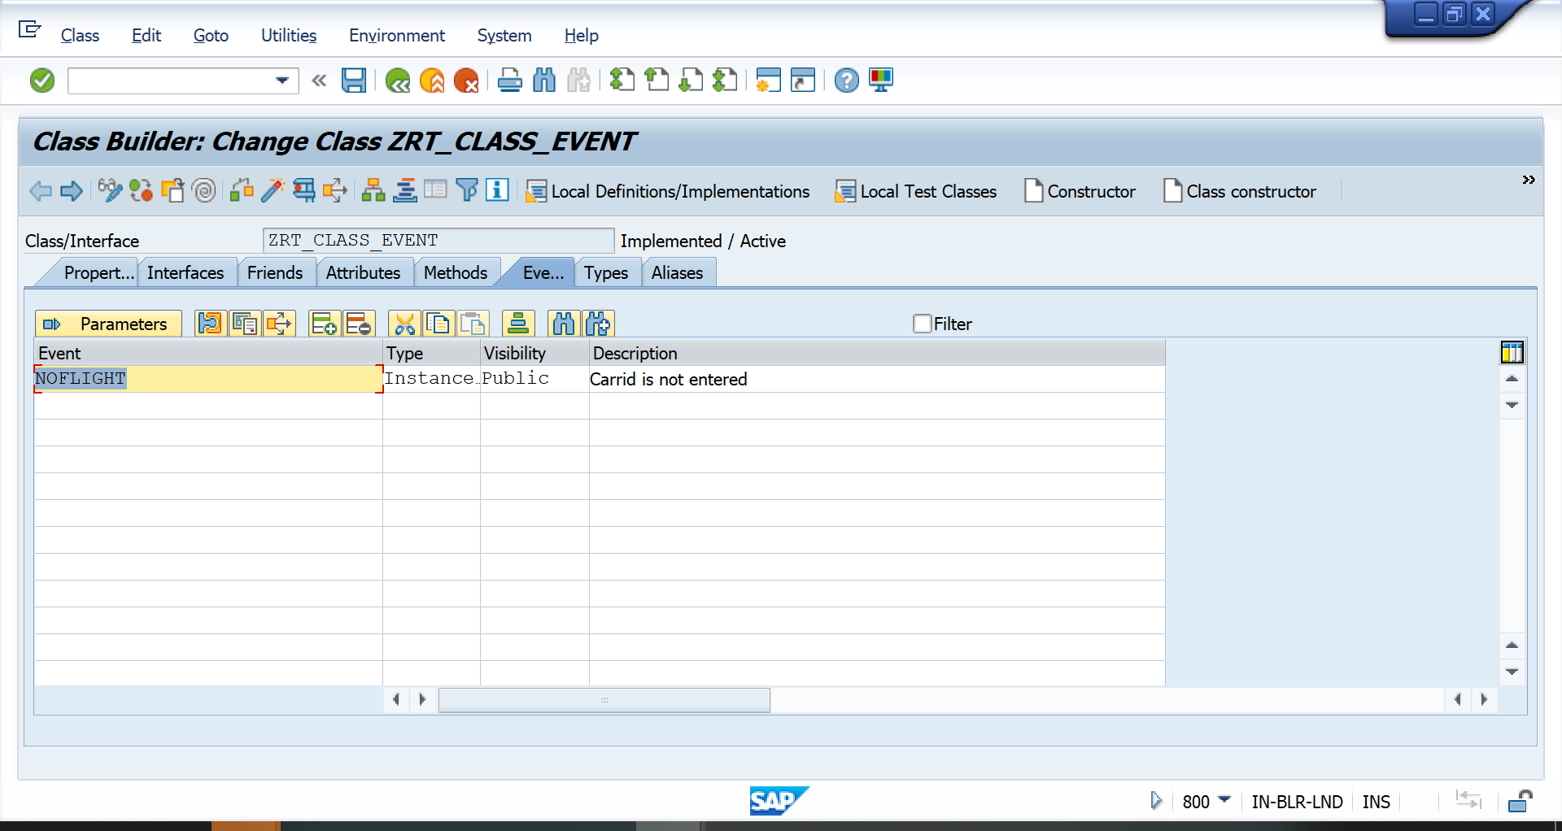

6.Create one more method

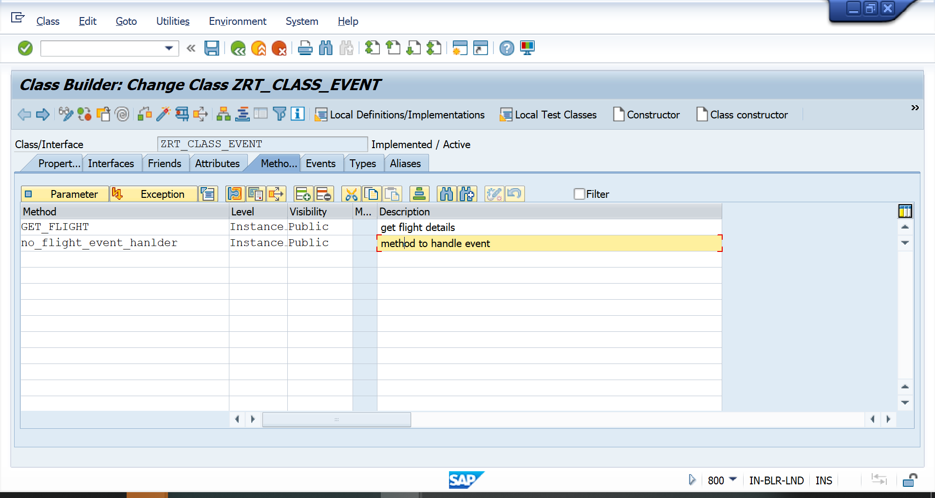

7.Add Logic in the method.

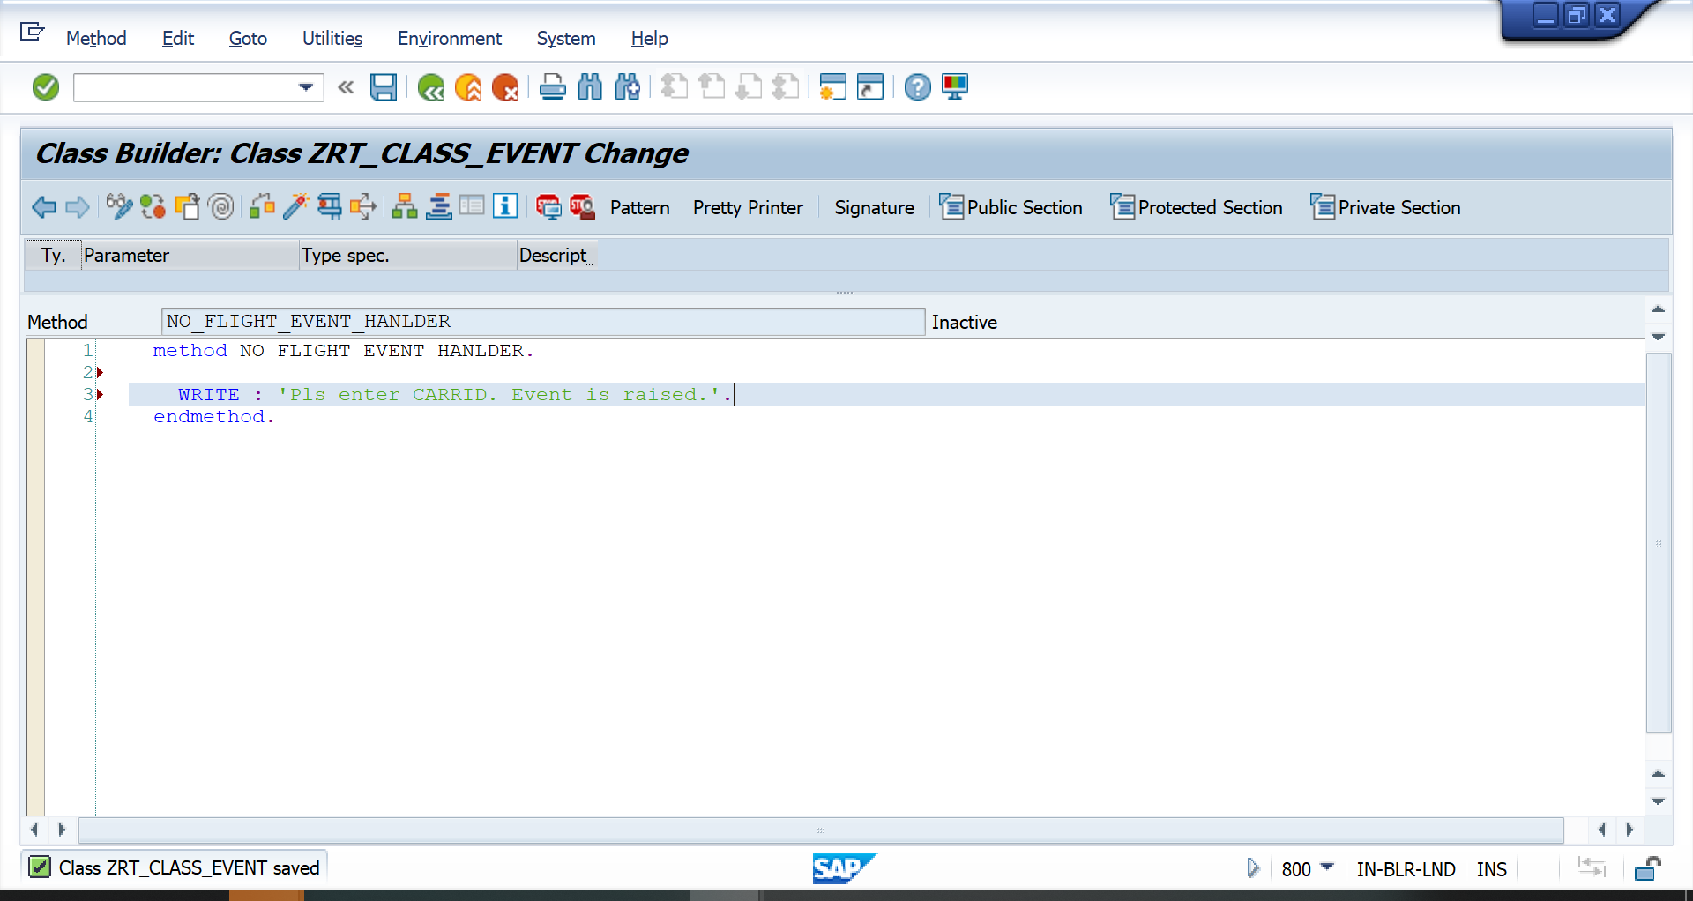

8. Select the method and click on the DetailView Icon

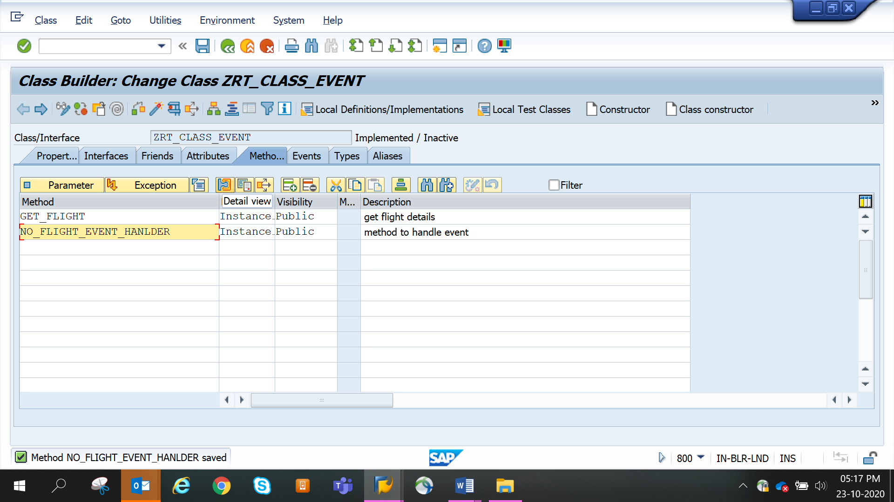

10.In the pop up window, give the class name and Event name as shown.Click change.

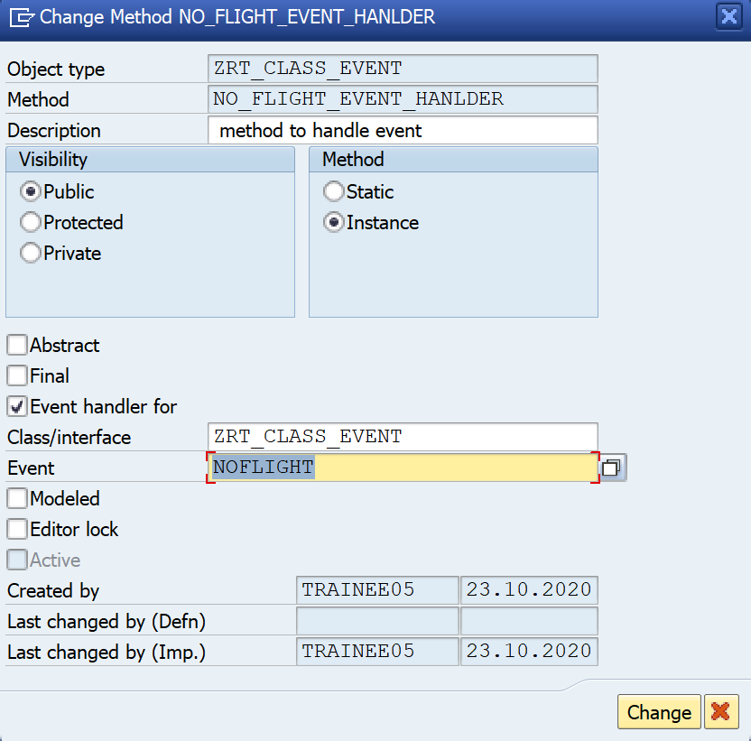

11.Notice the method is turned into event handler method as the blue icon appears against the method.

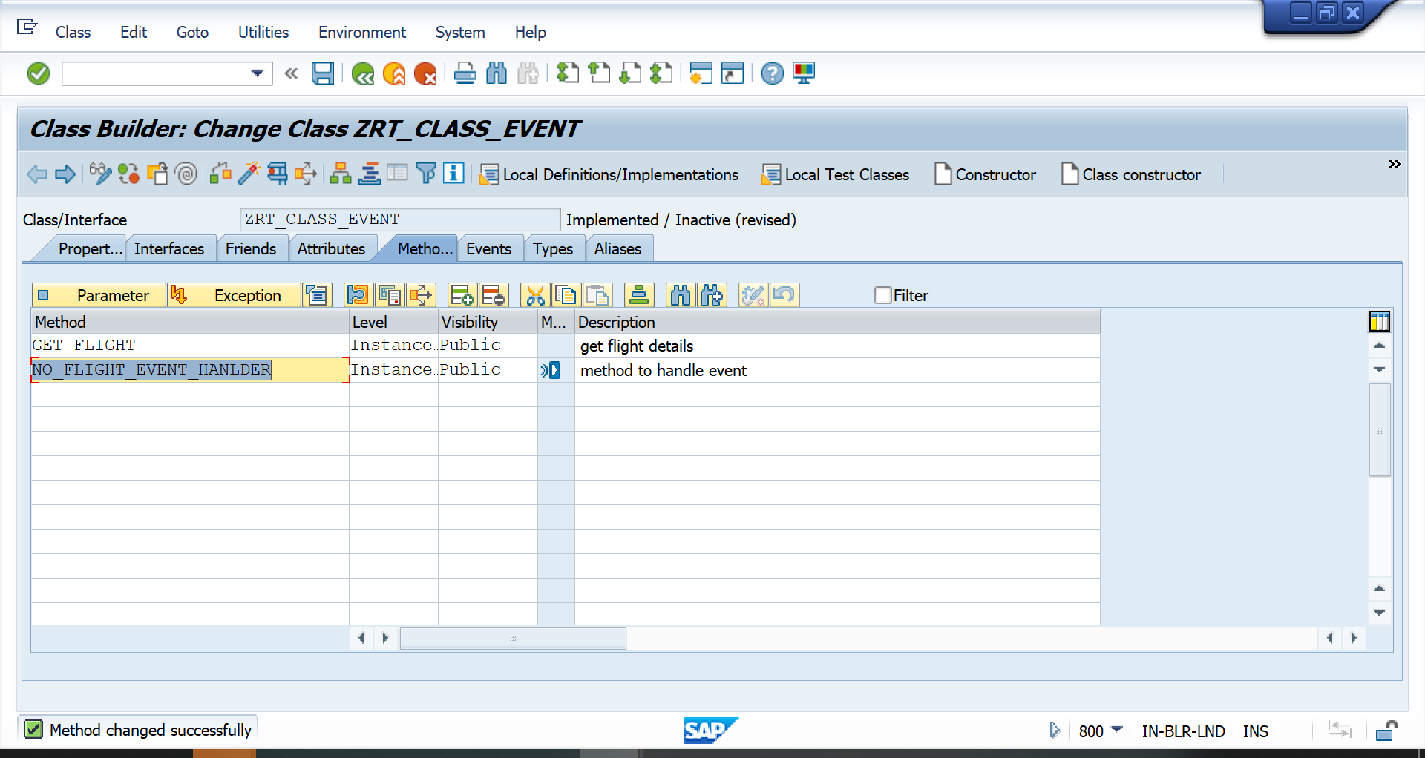

12. Create se38 program . Add below code.

REPORT ZGT_CLASS2.  
PARAMETERS P_CARRID TYPE SFLIGHT-CARRID.  
DATA : OBJ TYPE REF TO ZCL_CLASS2. "class decleration  
DATA WA_SFLIGHT TYPE ZLT_SFLIGHT. "work area to store flight data  
DATA IT_SFLIGHT TYPE ZTT_SFLIGHT_RT. "work area to store flight data  
  
. "flight input  
  
CREATE OBJECT OBJ. "create object for flight  
SET HANDLER OBJ->NO_FLIGHT_HANDLER FOR OBJ. "register event handler method  
  
START-OF-SELECTION.  
  CALL METHOD OBJ->GET_FLIGHT "call method  
    EXPORTING  
      IM_CARRID  = P_CARRID  
    IMPORTING  
      EX_SFLIGHT = IT_SFLIGHT.  
  
  
   LOOP AT lt_sflight INTO wa_sflight.  
    WRITE : / wa_sflight-carrid,  
    wa_sflight-connid.  
  ENDLOOP.

13.Execute without CARRID. You will get the message saying enter carrid.

